Project Documentation – Crop Yield Prediction (AI + ML Project)

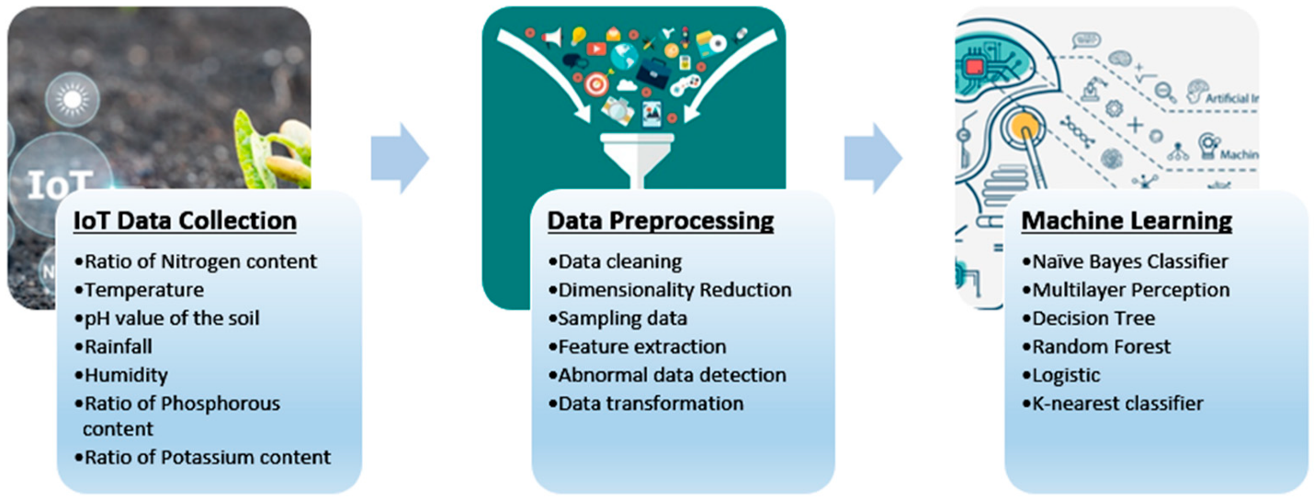

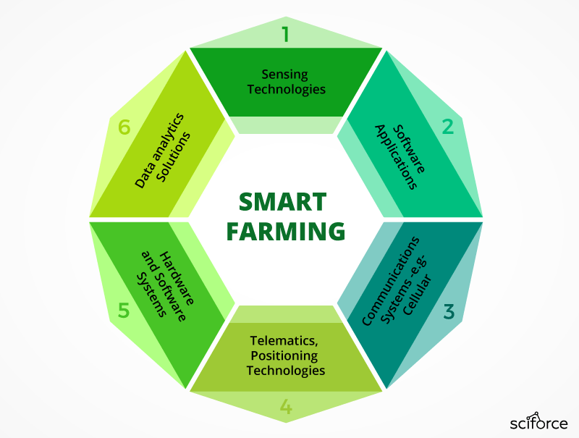

1. Project Title
AI-Based Crop Yield Prediction System Using Machine Learning

2. Project Duration
1 Month (4 Weeks)
Type: Client-side project OR portfolio project
Dataset: 100k synthetic dataset (you already downloaded)

3. Project Overview
Agriculture is highly impacted by temperature, rainfall, soil nutrients, fertilizer quantity, and farming practices.
Farmers often struggle with:
- Unpredictable weather
- Wrong fertilizer ratios
- Soil data not used effectively
- Market supply uncertainty
- Yield estimation errors
This project builds a Machine Learning model to accurately predict crop yield (in tonnes) using environmental factors, soil quality, and farming inputs.
It also includes:
- Data preprocessing
- EDA & insights
- Model building + optimization
- Dashboard creation
- Deployment option
- Documentation & final project report

4. Business Problem Statement
Agriculture suffers due to lack of data-driven decision-making.
Farmers need accurate predictions for:
- Crop planning
- Fertilizer optimization
- Water consumption
- Market supply-demand
- Reducing losses
This project solves it using AI-powered predictions.

5. Project Objectives
✔ Predict crop yield
✔ Build ML models & compare performance
✔ Identify key parameters affecting yield
✔ Create a Power BI/Streamlit dashboard
✔ Deploy model (optional)
✔ Deliver complete documentation

6. Dataset Description (100K Rows)
Features Included:
Feature | Description
Region | North/South/East/West/Central
Crop Type | Wheat, Rice, Maize, Soybean, etc.
Soil pH | Soil acidity
Rainfall (mm) | Seasonal rainfall
Temperature (°C) | Avg temp
Humidity (%) | Moisture
Land Area (Acres) | Farm size
Fertilizer Type | Organic, Urea, DAP, NPK
Fertilizer Quantity | kg
Pesticide Used | Liters
Yield (Tonnes) | Target variable

7. Tools & Technologies
- Python
- NumPy, Pandas
- Matplotlib, Seaborn
- Scikit-Learn
- XGBoost (optional)
- Power BI / Tableau
- Streamlit / FastAPI

8. Project Workflow (End-to-End)
- Data understanding
- Data cleaning
- EDA (graphical analysis)
- Feature engineering
- Feature selection
- Train-test split
- Model training
- Hyperparameter tuning
- Model evaluation
- Deployment
- Dashboard
- Documentation

9. Exploratory Data Analysis (EDA)
You will generate insights like:
- Crop-wise average yield
- Region-wise production
- Fertilizer impact analysis
- Rainfall vs Yield relationship
- Temperature stress impact
- Soil pH vs crop performance
- Heatmaps, boxplots, distribution graphs

10. Feature Engineering
Add new important features:
- Soil Health Score
- Fertilizer Efficiency Index
- Temperature Stress Score
- Moisture Index
- Region-Based Weighted Yield

11. Machine Learning Models
Models to train:
- Linear Regression
- Random Forest Regressor
- XGBoost Regressor
- CatBoost Regressor
- ANN (optional)
Evaluate using:
- R² score
- RMSE
- MAE

12. Deployment (Optional)
Deploy the prediction model using:
- Streamlit Web App
- OR FastAPI Backend
- OR Flask + HTML UI
Cloud Hosting Options:
- Render
- AWS EC2
- PythonAnywhere

13. Dashboard (Power BI / Tableau)
Dashboard Sections:
- Region-wise production map
- Crop-wise yield comparison
- Soil analysis
- Fertilizer optimization
- Weather impact charts

14. Final Deliverables
You will deliver:
✔ Dataset (100k)
✔ Cleaned dataset
✔ EDA report
✔ Model file (.pkl)
✔ Deployment script
✔ Dashboard file
✔ Final PPT
✔ Full 1-month documentation

15. 1-Month Timeline (Weekly Breakdown)

📌 Week 1 – Data + Cleaning + EDA
✔ Load dataset (100k)
✔ Check missing values
✔ Handle outliers
✔ Univariate analysis
✔ Bivariate analysis
✔ Correlation study
✔ Prepare EDA report

📌 Week 2 – Feature Engineering + Model Building
✔ Create new features
✔ Split into train & test
✔ Train baseline models
✔ Compare model scores
✔ Choose best model
✔ Save trained model

📌 Week 3 – Optimization + Dashboard
✔ Hyperparameter tuning (GridSearchCV)
✔ Improve RMSE
✔ Build dashboard in Power BI
✔ Export insights

📌 Week 4 – Deployment + Documentation
✔ Build Streamlit/FastAPI app
✔ Deploy online
✔ Prepare project documentation
✔ Create final PPT
✔ Submit final report

16. Conclusion
This project provides a complete industry-level solution for predicting crop yields using Machine Learning.
It can be expanded by integrating:
- Satellite imaging
- IoT soil sensors
- Real-time weather APIs

